For Numerical/Quantitative Data:
- Dotplots
- Stem and Leaf Plot
- Histograms
- Boxplots
- Probability Plots
Dot Plot
- >#This code makes a dotplot in R in a file called Students_Grades for the variable FINAL
- >dotchart(Student_Grades$FINAL)
- 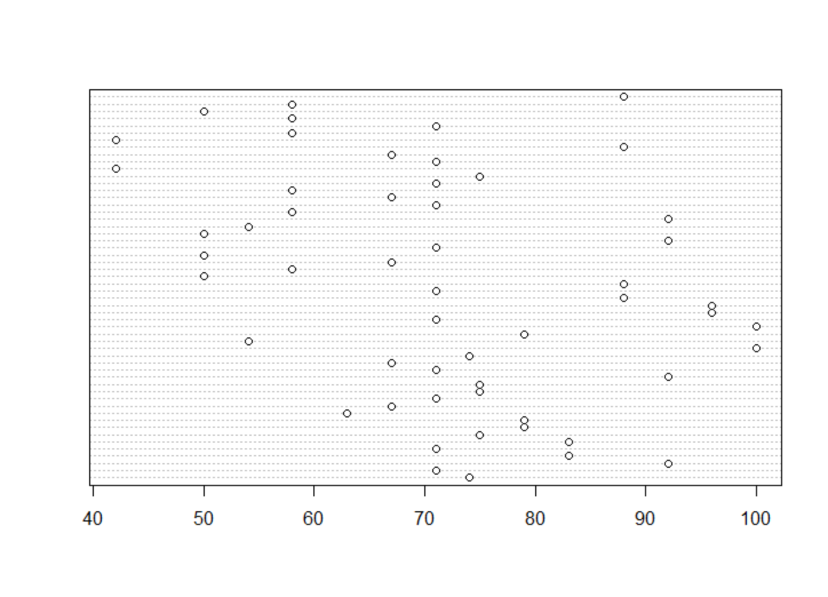
- >#This code makes a dotplot in R in a file called Students_Grades for the variable FINAL
- >#adding a title and labels
- >dotchart(Student_Grades$FINAL, main = "Distribution of Final Grade for Class of 54 Students", xlab = "Grade")
- 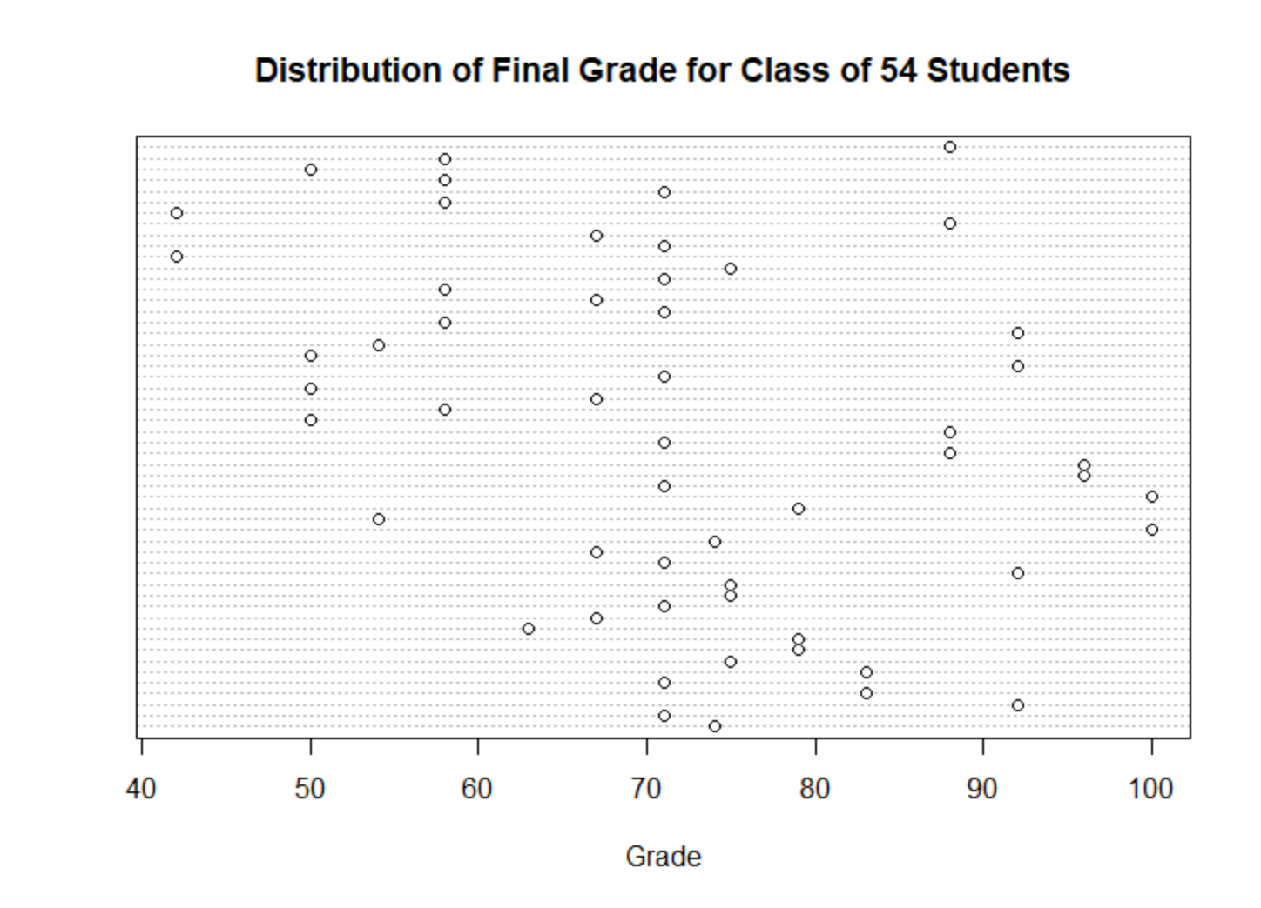
Stem and Leaf Plot
- >#This code makes a stem and leaf plot in R in a file called Students_Grades for the variable FINAL
- >stem(Student_Grades$FINAL)
- See slides for images
Histogram
- >#This code makes Histograms in R in a file called Students_Grades for the variable FINAL
- >hist(Student_Grades$FINAL,breaks = 6, right = FALSE, main = "Distribution of
- 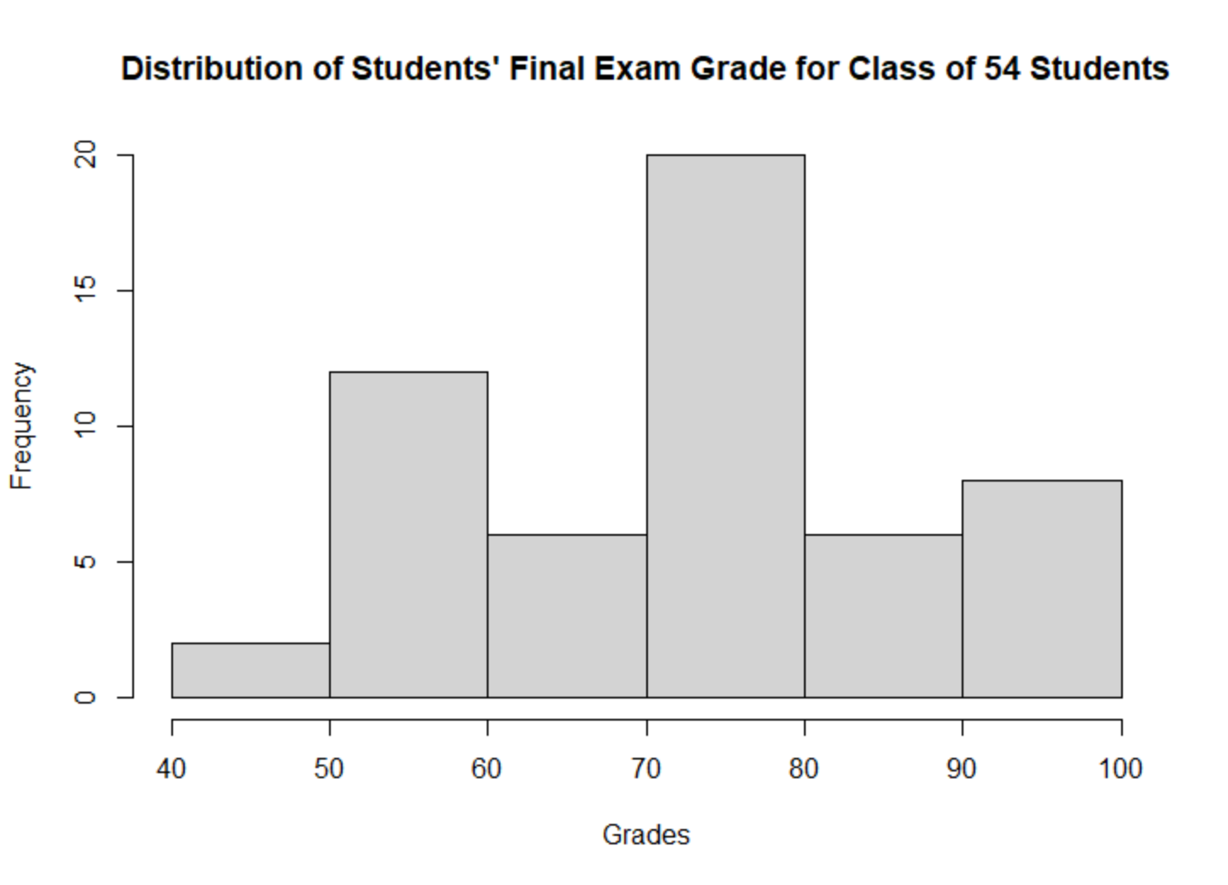
- Students' Final Exam Grade for Class of 54 Students", xlab = "Grades")
- If you do not add right = FALSE, the default of R is a histogram that includes the right cutpoint value in a particular bin. This is not standard, so we must add the command right = FALSE, otherwise we would get the following nonstandard histogram:
- 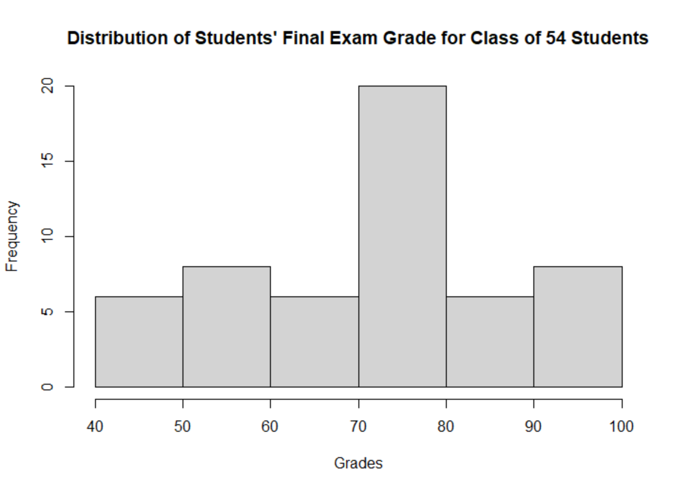
Boxplot
- >#This code makes a boxplot in R in a file called Students_Grades for the variable FINAL
- >boxplot(Student_Grades$FINAL)
- 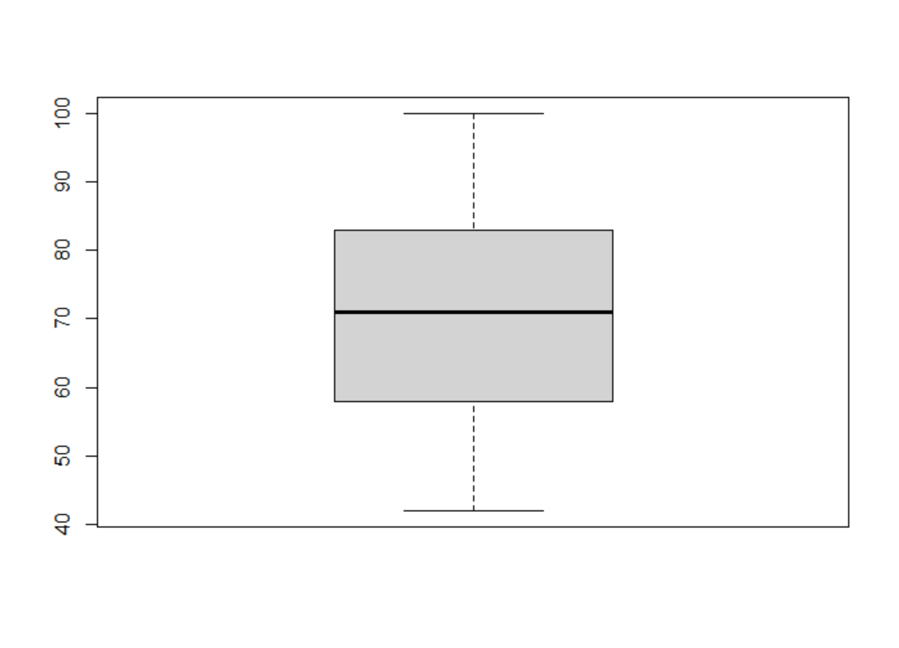
- >#We would like it to be horizontal and with titles
- >boxplot(Student_Grades$FINAL, horizontal = TRUE,xlab="Grades for Final Exam",main = "Distribution of Final Exam Grades for Class of 54 Students")
- 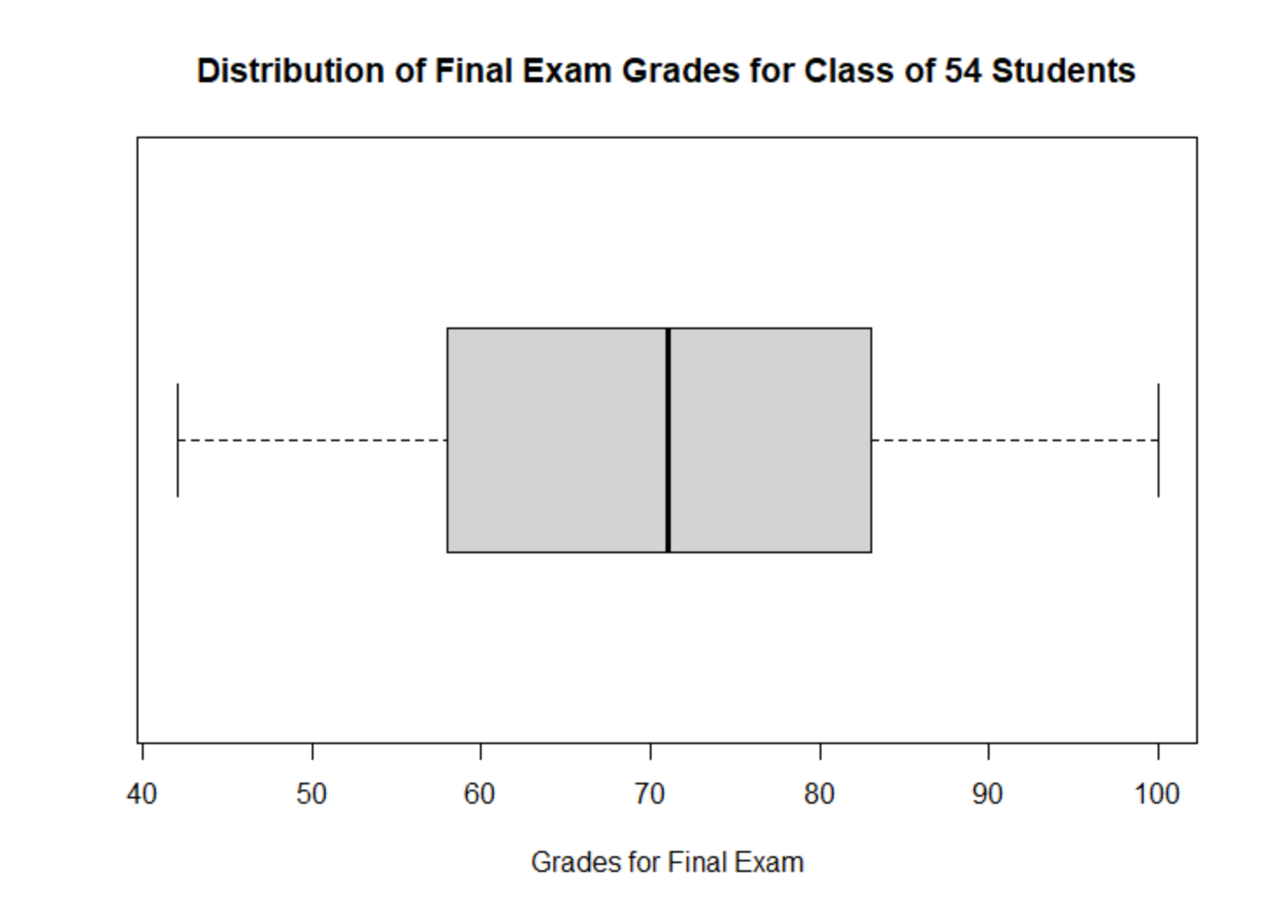
- >#This Boxplot will be blue and it also has outliers. So, you will see what a boxplot in R looks like when there are
- ># outliers
- >boxplot(Student_Grades$Test1, horizontal = TRUE,xlab="Grades for Test 1",main = "Distribution of Test 1 Grades for Class of 54 Students", col = "blue")
- 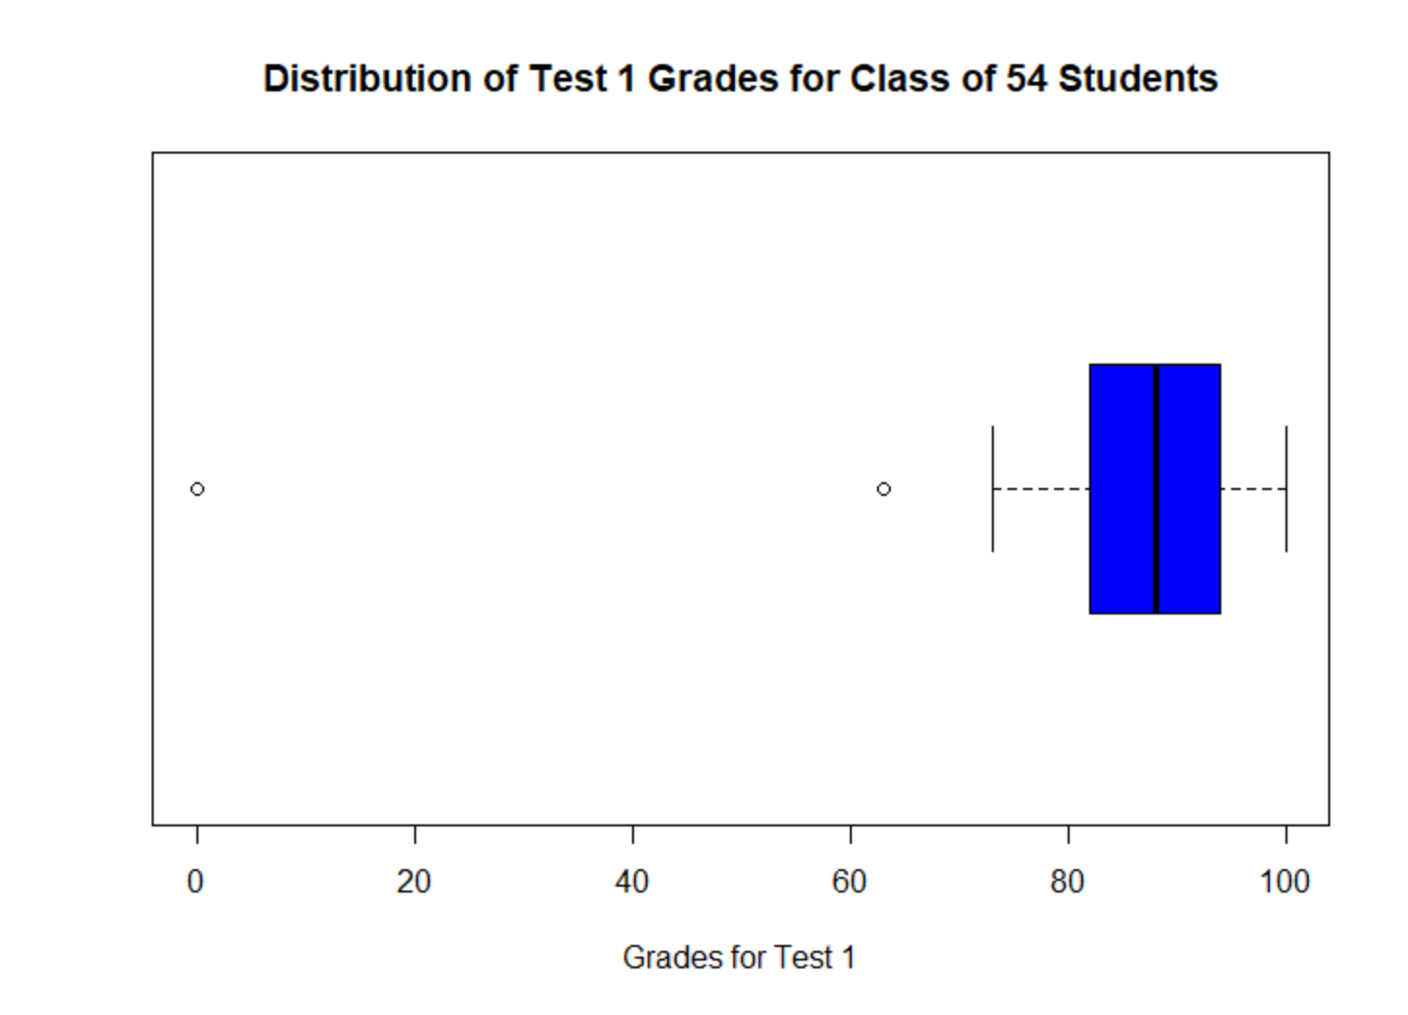
Probability Plot
- Checking for normality – data must look approximately linear
- Creating the probability plot with a line
- >#Getting a Probability Plot with line
- > qqnorm(Student_Grades$FINAL,main = "Probability Plot for Final Exam Grades")
- > qqline(Student_Grades$FINAL)
- 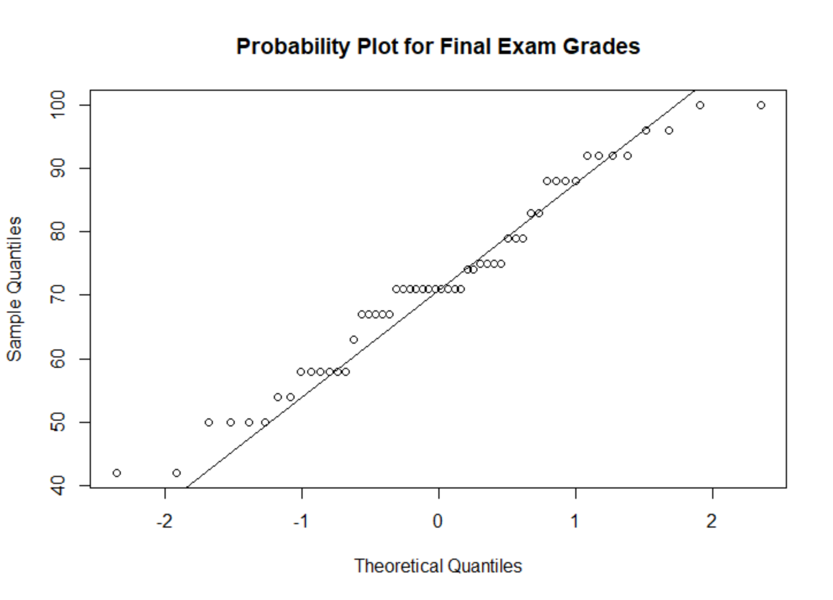
- Creating the probability plot with a line
- >#Getting a Probability Plot with green colored line
- > qqnorm(Student_Grades$Test1,main = "Probability Plot for Test 1 Grades")
- > qqline(Student_Grades$Test1, col="green")
- 